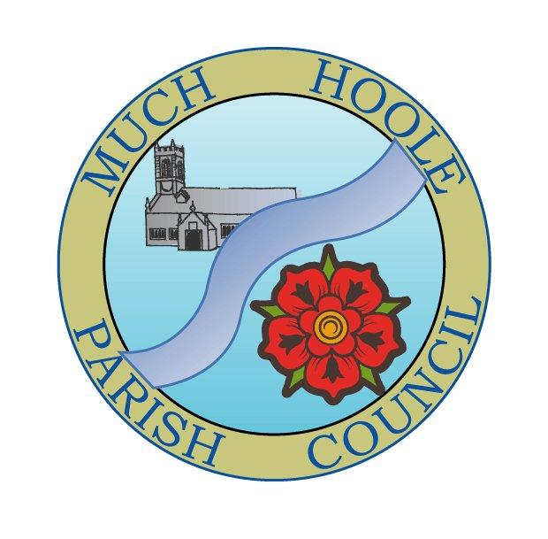 | MUCH HOOLE PARISH COUNCIL  NOTICE OF MEETING
You are hereby summoned to attend the Meeting of Much Hoole Parish Council to be held at 7.30pm on Monday 11th July 2022. The meeting will be held at the Venue (Hoole memorial village hall) Liverpool Road.
Russ Weaver, Clerk

AGENDA
1. | Apologies for Absence  To receive apologies for absence.
2. | Declaration of Interests and Dispensations  - To receive declarations of interest from Councillors on items on the agenda  - To receive written requests for dispensations for disclosable pecuniary interests (if any)  - To grant any requests for dispensation as appropriate
3. | Minutes of the Previous Meetings  To resolve to approve as a correct record the Minutes of the Council Meeting held on the 13th June 2022
4. | Public Time  To invite and listen to issues raised by members of the public.
5. | Reports from other meetings  The Council will receive reports from meetings where Councillors have attended as representatives
6. | Off Road Cycle Track  To consider any updates on the Cycle track and resolve any actions required.
7. | Finance and Audit  To resolve to authorise payment of the following:  - To resolve to release the previously pledged grants of £11,000 (2 x £5,500 agreed in minutes of 9th May 2022 and 11th October 2021)  - To note that MHPC has submitted an application for £500 and £300 to LCC for Local Delivery of maintenance of footpaths and biodiversity projects (contribution to community fruit garden agreed in June 2022)  - To resolve to pay the Clerk £480 (net for June and July 2022 pay)  - To resolve to pay HMRC £120 (June and July 2022 PAYE)  - To Resolve to pay Clerk £10.80 mileage  - To NOTE the Budget v Spend position as at 30th June 2022  - To NOTE that the annual accounts have been submitted to PKF Littlejohn auditors within the necessary timescale and the notices of public rights are displayed
8. | Community Projects update  To receive an update on any ongoing projects  - To note that planning approval has been received for the village welcome signs and manufacture is now proceeding.
9. | Car Parking  Due to ongoing problems in traffic flow due to parking problems, particularly around Liverpool Old Road recreation ground, the Council is asked to consider an approach to South Ribble Borough Council to explore the feasibility of increasing roadside parking by moving the boundary hedge of the recreation ground adjacent to the gate area to allow for chevron parking on Liverpool Old Road Road  To receive any other issues related to car parking.
10. | Planning  07/2022/00553/OUT June 27, 2022  Outline planning application for the partial demolition of an existing commercial building  and the erection of up to 5 no. dwellings. (details of access, layout and scale, all other  matters reserved)Taylor House,Carr Lane, Much Hoole,Preston, Lancashire  PR4 4TH
11. | Village Hall development update  To receive and note a report on the progress of The Venue
12. | Hedge obstructions and highways issues  To note:  - The Clerk has requested LCC to cut the hedges back on Liverpool Old Road at the Recreation ground boundary  - The Clerk has also requested action be taken to remove overhanging hedges obstructing the pavements on Barnfield  - The Council is asked to note that a new app ‘Report it on the go’ has been launched by LCC allowing residents to report highways issues and requested repairs directly to LCC. This will be advertised on the website and notice boards.
13. | Footpaths  To receive an update on any footpath repair or maintenance issues
14. | Grants  The availability of grants is on the Council website and notices will be posted on the notice boards once the statutory audit notices have been removed.  No new grant applications have been received
15. | Transparency statement  Proposal:  Following a number of posts on the Next Door website regarding the Council is operating in a less than transparent manner, it is proposed to post the draft transparency statement on  - The Next Door site  - The Council website
16. | Items for next agenda
17. | Date of Next Meeting  The Parish Council to agree the date of the next meeting as 7.30pm Monday 12th September 2022, to be held at ‘The Venue’, Liverpool Road, Much Hoole.

